

|  |  |
| --- | --- |
| **Department** | **Engineering Mathematics and physics** |
| **Division** | **اعدادي هندسة** |
| **Academic Year** | **2019/2020 preparatory** |
| **Course name** | **computer** |
| **Course code** | **ECE001** |

**Name : ADEL ADEL MOSTAFA IBRAHIM ELGENDY**

**B.N: 434**

**Date : 28/5/2020**

**Topic:**  **mobile computing**

**Github link :**

**Github page :**



**Application brief : mobile computing**

Mobile computing is human–computer interaction during which a computer is predicted to be transported during normal usage, which allows for transmission of knowledge , voice and video. Mobile computing involves mobile communication, mobile hardware, and mobile software. Communication issues include unplanned networks and infrastructure networks also as communication properties, protocols, data formats and concrete technologies. Hardware includes mobile devices or device components. Mobile software deals with the characteristics and requirements of mobile applications. Mobile computing may be a generic term that refers to a spread of devices that allow people to access data and knowledge from wherever there . Mobile computing transports data, voice, and video over a network via a mobile device. Mobile devices are often connected to an area network (LAN), or they will cash in of Wi-Fi or wireless technology by connecting via a wireless local area network (WLAN). mobile services also provide mobile computing through their service plans.

**The Benefits of Mobile Computing**

There are many benefits to mobile computing including the power to urge directions, entertain yourself when bored, do business, and more, including:

Connectivity : you'll stay connected to all or any sources in the least times.

Social Engagement : you'll interact with a spread of users via the web .

Personalization : you'll tailor your mobile computing to your individual needs.

**Mobile Devices**

"Mobile device" may be a generic term wont to ask a good range of devices that allow people to access data and knowledge from anywhere at any time. These devices are available a variety of sizes, from people who slot in your pocket, like cell phones, to tablets, to laptops. Mobile computing can use cellphone connections to form phone calls, also on hook up with the web . The list of mobile devices include:

Laptops.

Smartphones.

Tablets.

eReaders (i.e. Kindle).

Handheld Gaming Devices (i.e. Nintendo 3DS).

Wearable Devices (i.e. Apple Watch).



**Source code:**

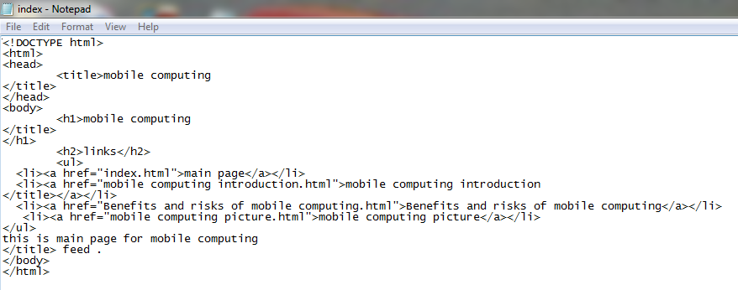

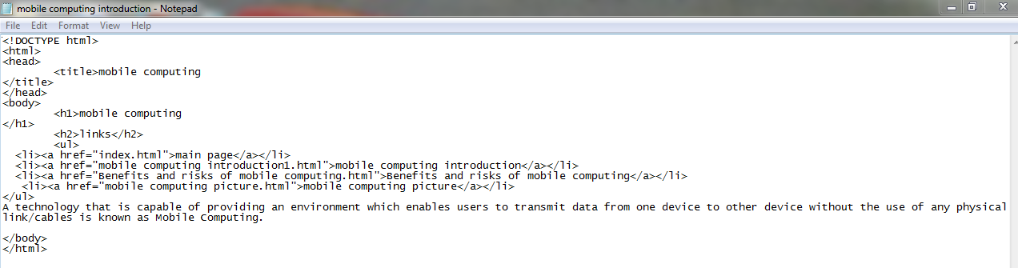

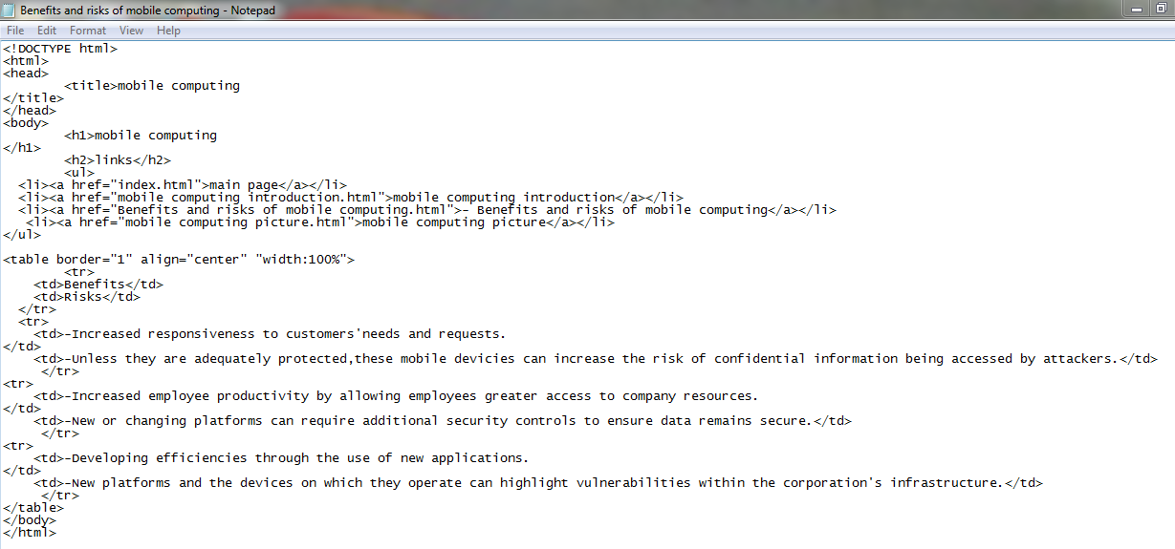

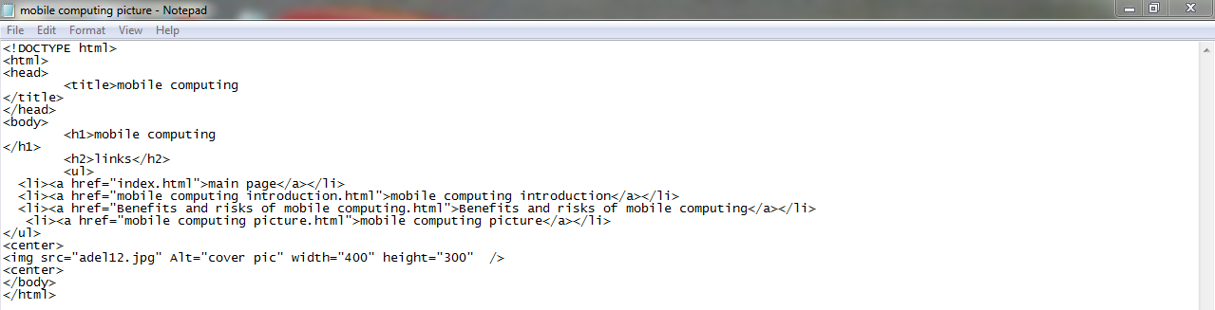

**Screenshots :**

**(1)**

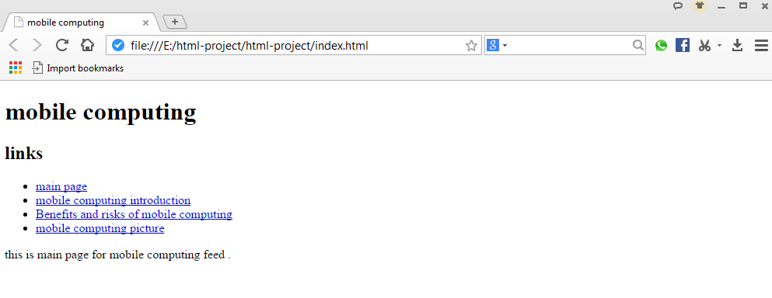

**(2)**

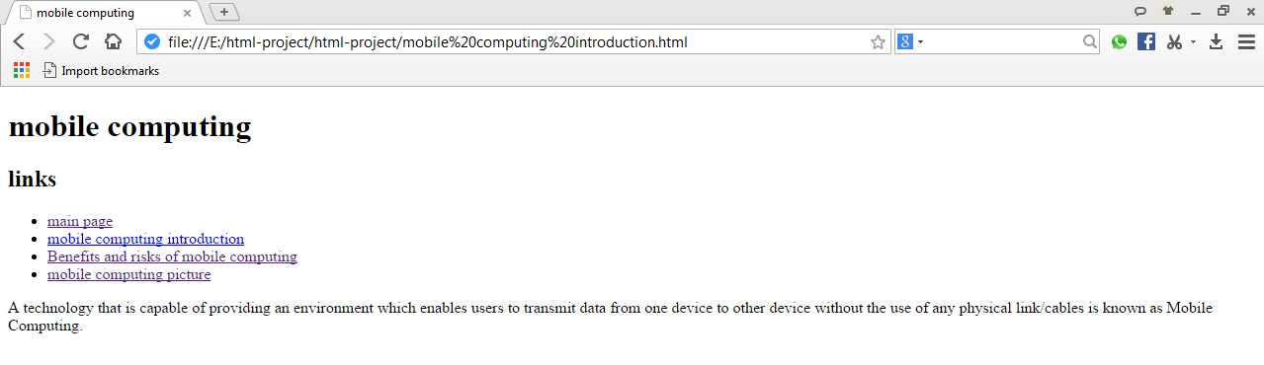

**(3)**

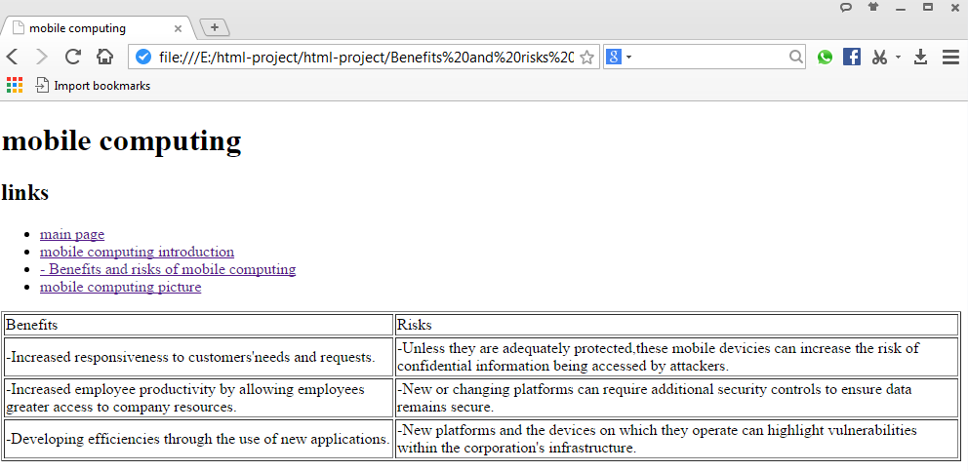

**(4)**

